**Diabetic Retinopathy Diagnosis**

**By**

**Crains Patel [16BCE021]**

**Het Brahmbhatt [16BCE027]**



**DEPARTMENT OF COMPUTER SCIENCE & ENGINEERING**

**Ahmedabad 382481**

i**Diabetic Retinopathy Diagnosis**

**Minor Project**

Submitted in fulfillment of the requirements

For the degree of

**Bachelor of Technology in Computer Engineering**

By

**Crains Patel [16BCE021]**

**Het Brahmbhatt [16BCE027]**

Guided By

**Prof. Ashwin Verma**

**[DEPARTMENT OF COMPUTER SCIENCE & ENGINEERING]**



**DEPARTMENT OF COMPUTER SCIENCE & ENGINEERING**

**Ahmedabad 382481**

ii

**CERTIFICATE**

This is to certify that the Minor Project entitled “Diabetic Retinopathy Diagnosis” submitted by Crains Patel(16bce021) and Het Brahmbhatt(16bce027), towards the partial fulfillment of the requirements for the degree of Bachelor of Technology inInformation Technology of Nirma University is the record of work carried out by him/her under my supervision and guidance. In my opinion, the submitted work has reached a level required for being accepted for examination.

Prof. Ashwin Verma Dr. Madhuri Bhavsar

Assistant Professor Dept. of Computer Science & Engineering,

Department of Computer Science & Engg., Institute of Technology,

Institute of Technology, Nirma University,

Nirma University, Ahmedabad

Ahmedabad

iii

**ACKNOWLEDGEMENT**

**We would like to express our deepest appreciation to all those who provided us the possibility to complete this report. We acknowledge with thanks the support rendered by Prof. Ashwin Verma (Department of Computer Science and Engg.), under whose aegis we were able to complete the task in a given period of time. We also appreciate the constructive suggestions given by our friends to further enhance the content of the report.**

**At the home front, we are extremely grateful to our family members for the support and encouragement we got from them in successfully completing the report.**

iv

**ABSTRACT**

Diabetes is the leading cause of vision impairment throughout the world. Almost 80% of all the patients suffering from diabetes for more than 10 years have some or the other kind of vision problem. In this paper we have devised a technique using Deep Learning and Machine Learning increases the accuracy of detection of the 5 different stages of DR in human eye. Funduscopic screening images of eye are used as input. The images are preprocessed and then it is passed to a pre-trained model. Typically, there is a period delay in announcing and intercession, aside from the money related cost and danger of visual impairment related with it. But using this model the time delay can be reduced. The target output is divided into five different classes showing the different stages of diabetic retinopathy. Different features of the eye are extracted using the deep model.

v

**CONTENTS**

Certificate

Acknowledgement

Abstract

Table of Contents

List of figures

List of tables

**Chapter 1 Introduction 1**

1.1 General 1

1.2 Important Features 2

1.3 Objective of study 4

1.4 Scope of Work 4

**Chapter 2 Dataset**

2.1 Ben Graham’s Preprocessing 5

2.2 Dimensions of Dataset 5

**Chapter 3 Proposed Methodology**

3.1 VGG-19 Network 6

3.2 Residual Connections 6

3.3 Overfitting Correction Techniques 7

**Chapter 4 Model Architecture 11**

4.1 Architecture 12

**Chapter 5 Summary and Conclusion**

5.1 Summary 14

5.2 Conclusions 14

**References**

vi

**List of figures**

* 1. Hemmorhages
  2. Blood Vessels
  3. Exudates
  4. Aneurysms
  5. Optic Disc

**2.1** Ben Graham’s preprocessing

**3.1** VGG19

**3.2** Residual Connections

**4.1** Architecture

vii

**Chapter - 1 Introduction**

**1.1 General**

Diabetic Retinopathy is the main cause of blindness and it is the leading cause of blindness and problems related to the eye. The high level of glucose in the eye deteriorates the blood vessels in the retina which are visible in the fundus images of the retina. Timely diagnosis of the disease can reduce the impact of the disease. But in the initial phases of the disease it is very difficult to see even for the most experienced of the doctors. If the disease is diagnosed in the initial phases it can be cured by operation or by medication. Thus it is very important that the disease is diagnosed well in advance. Thus if this can be done using computers that it would be of great help to the humanity. The methods available in the domain are not very accurate and require better methods to increase the accuracy.

**1.2 Important Features**

There are five important features which are dominant in the retinal images of patients. They are as shown below:

1. Hemorrhages
2. Abnormal Growth of Blood vessels
3. Hard Exudates
4. Aneurysms
5. Optic Disc

1

The five important features are depicted in the image below

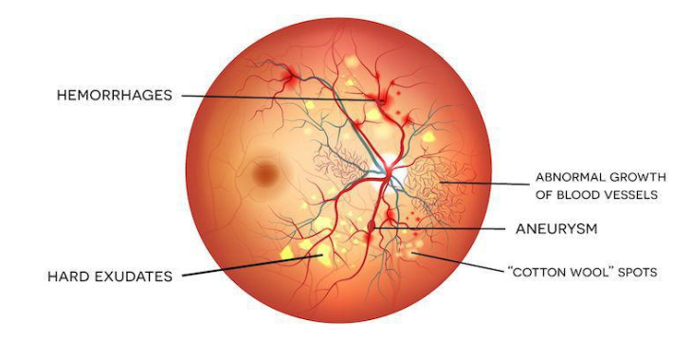

1.1

1. Exudates

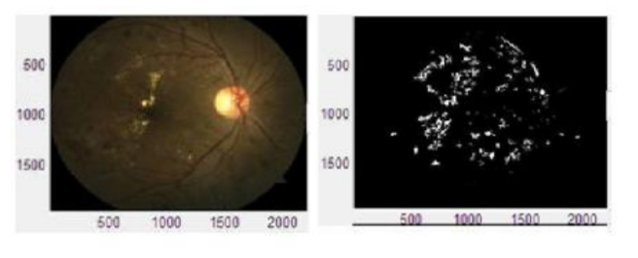

1.2

2

2. Aneurysms

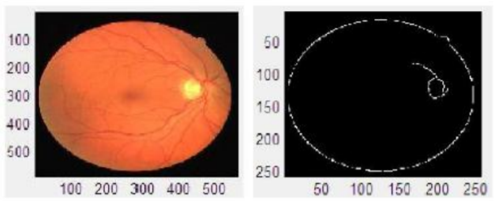

1.3

3. Optic Disc

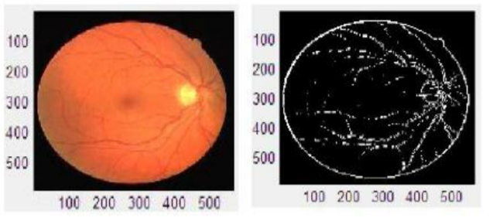

1.4

3

**1.3 Objective of Study**

The given report depicts the methodology developed to detect the level of DR in the patients. For the prediction the input images of the retina are taken and the model is trained on it. Certain concepts of deep learning are used so that the over fitting can be reduced. The model is used to get the level of DR detected in the fundus retinal images.The output is then classified into one of the 5 types.

**1.4 Scope of the work**

The scope of the work includes what is diabetic retinopathy,what are the important features on the basis of which the input image is classified and the proposed methodology.

4

**Chapter - 2 Dataset**

The dataset was imported from the aptos2019 competition which was being carried out on kaggle.The dataset was divided into training images and testing images.

**2.1 Ben Graham’s Preprocessing**

Initially the dataset is in the form of RGB format.Hence, the features are not properly visible.To make the features properly visible,the image is first converted into Grayscale format.After the image is converted into grayscale format Ben Graham’s preprocessing method is used which helps to extract the features properly.Finally the images will appear as shown below.

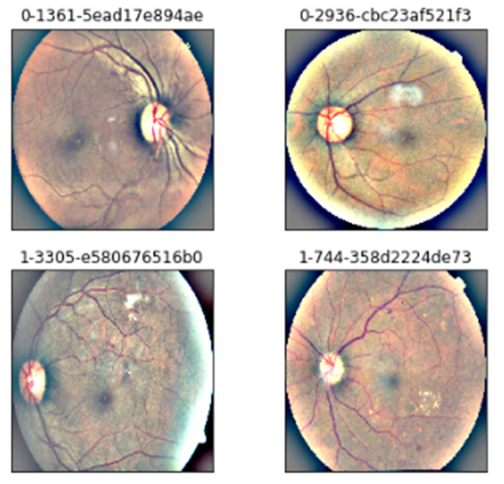

2.1

5

**2.2 Dimensions of the dataset**

The maximum width and height of the image is 4288 and 2848 respectively.The minimum width and height is 474 and 358 respectively.

The model input width is 2400 and the model input height is 358.The input dimensions of the images were different.So to unite them into one input dimension,zoom function is used.This function checks that the dimension of the input is the one which is mentioned.Thus through this it can be confirmed that whatever the input dimension maybe it will unite into one and after that it will be fed into the model.

6

**Chapter -3 Proposed Methodology**

**3.1 VGG-19 Network**

VGG network is named after the group of Oxford University which developed this network and it stands for Visual Geometry Group. In the VGG-19 network there are convolutional neural network. There are 19 layers in VGG-19 net. The architecture of VGG-19 net is as shown in the image below.

There are 16 convolutional layers and the last 3 layers are fully connected layers.

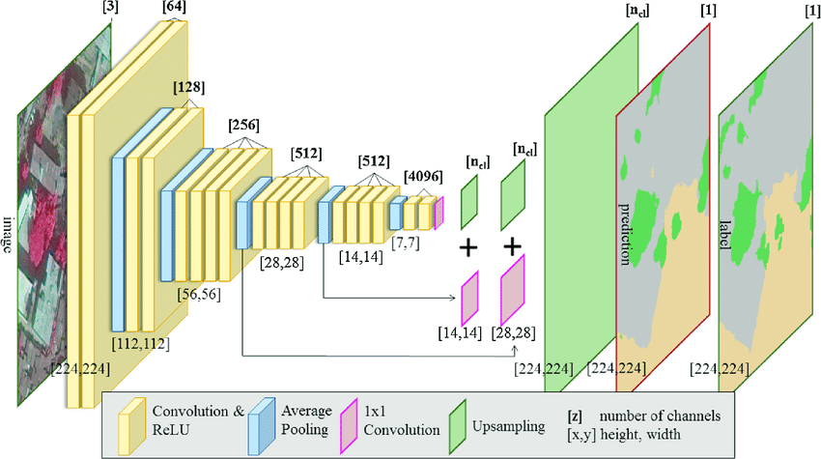

3.1

**3.2 Residual Connections**

Residual connections are added to the VGG net architecture so that the features can be enhanced and certain layers can be omitted. The residual connections help the model to overcome the problem of dimensionality. The images present are not very high resolution. Thus to pass the image

7

to such high number of layers without losing its important features it becomes important that the residual connections are added. It can also be taken care of with padding but it will include unnecessary computation. Thus adding residual connections is a good method.

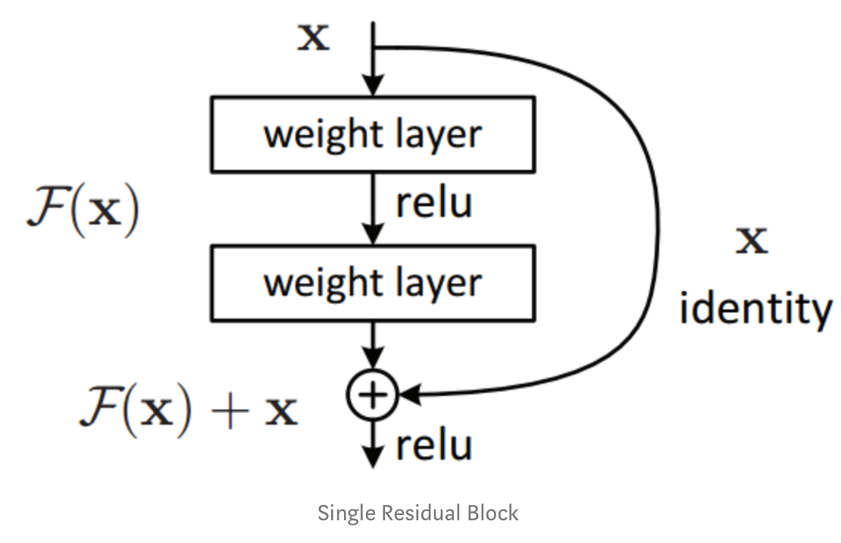

3.2

**3.3 Real Time Data Augmentation**

Input data in the neural network is often augmented to decrease over fitting and reduce the amount of computation. This helps in reducing overfitting. Real Time Data Augmentation is a method used to increase the speed of computation. According to a report this increases the speed by around 10x. Also this decreases the amount of space required by developing the images when the image is loaded and assigning only one label to the various augmented images. Real time data augmentation is very important here because the dataset is not very high and thus it becomes very necessary to reduce overfitting so that the model can work well with images other than that it has been tested on. Thus the main problems which can be tackled using Real Time Data Augmentation are reduction of overfitting on a sufficiently small dataset.

8

**3.4 Dropout**

Dropout of 25% is included in the network so that the layers are omitted with a probability of 0.25. This helps the individual neurons learn better. In a network without dropout the neurons are fed with the images again and again, which decreases their tendency to learn and they start to memorise. Thus when certain neurons are removed from the network the remaining neurons

have to take care of the weights and their weights are modified in such a manner. This helps the network to reduce overfitting.

9

**Chapter - 4 Model Evaluation**

**4.1 Architecture**

The architecture of the proposed model as shown. The conv layer represents the convolutional layer, mixed layer is the layer after concatenation with the residual layers.

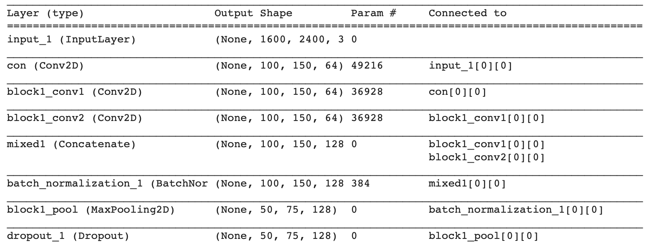

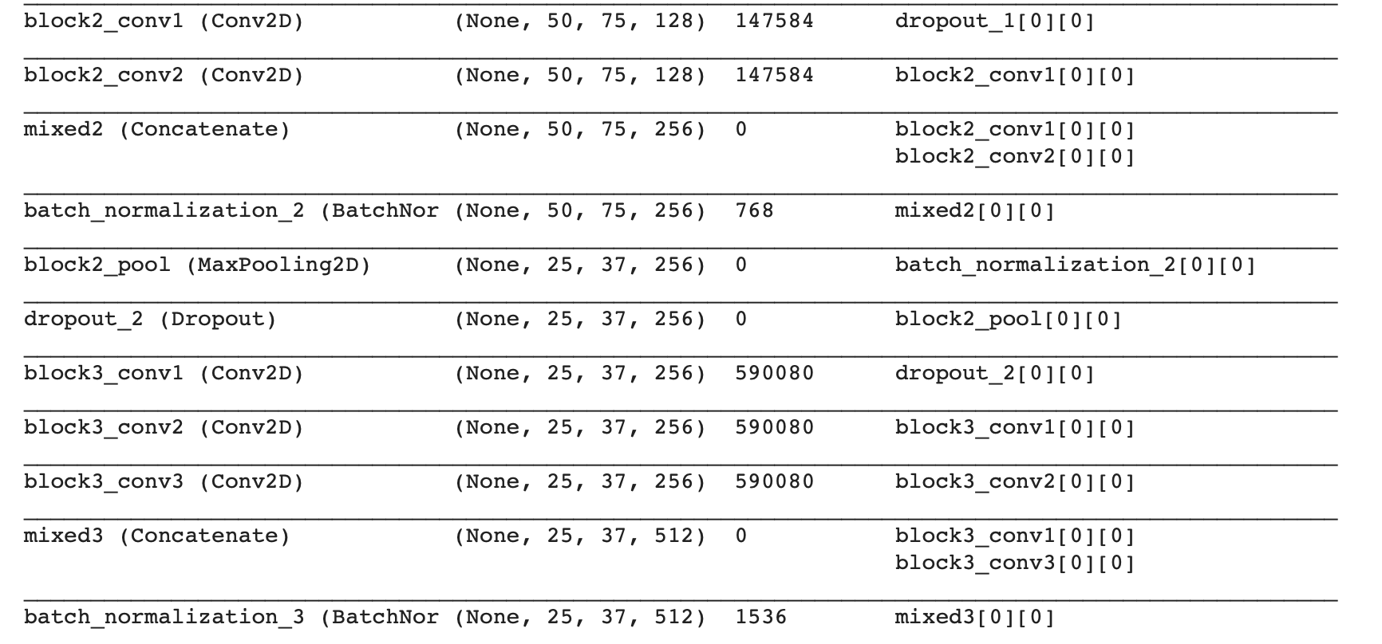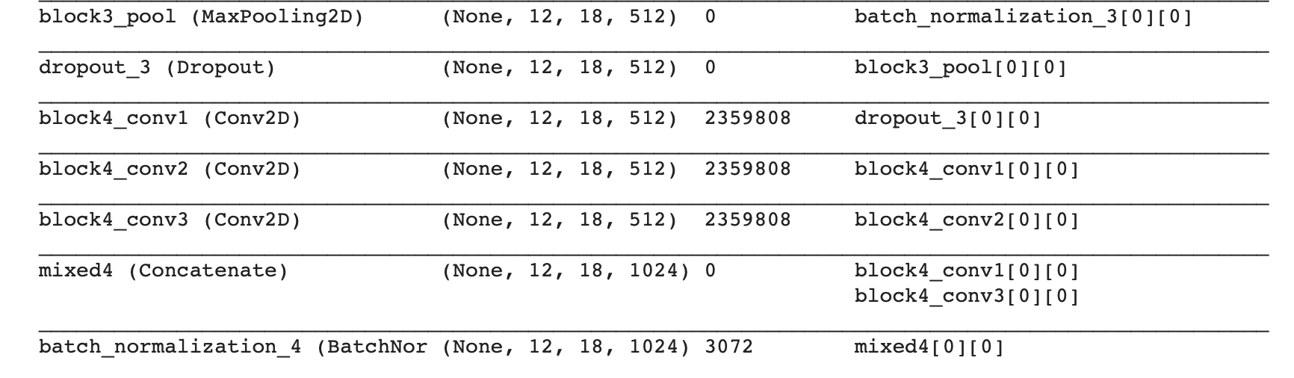

The input size of image is (2400,1600) which is fed into the system after preprocessing of the original images. Batch size is 32 and the number of epochs is 100. Real time data augmentation is kept on. Loss is calculated using ‘categorical_crossentrophy’ and the ‘rmsprop’ optimizer is used to train the model with learning rate 0.001. ‘Softmax’ activation function is used in the last layer for predictions of the five different classes.

**4.2 Output**

The output of the given model is as shown in the picture. The accuracy values are printed after 100 epochs on a dataset of around 2928 training images and around 1000 testing images with labeled data.

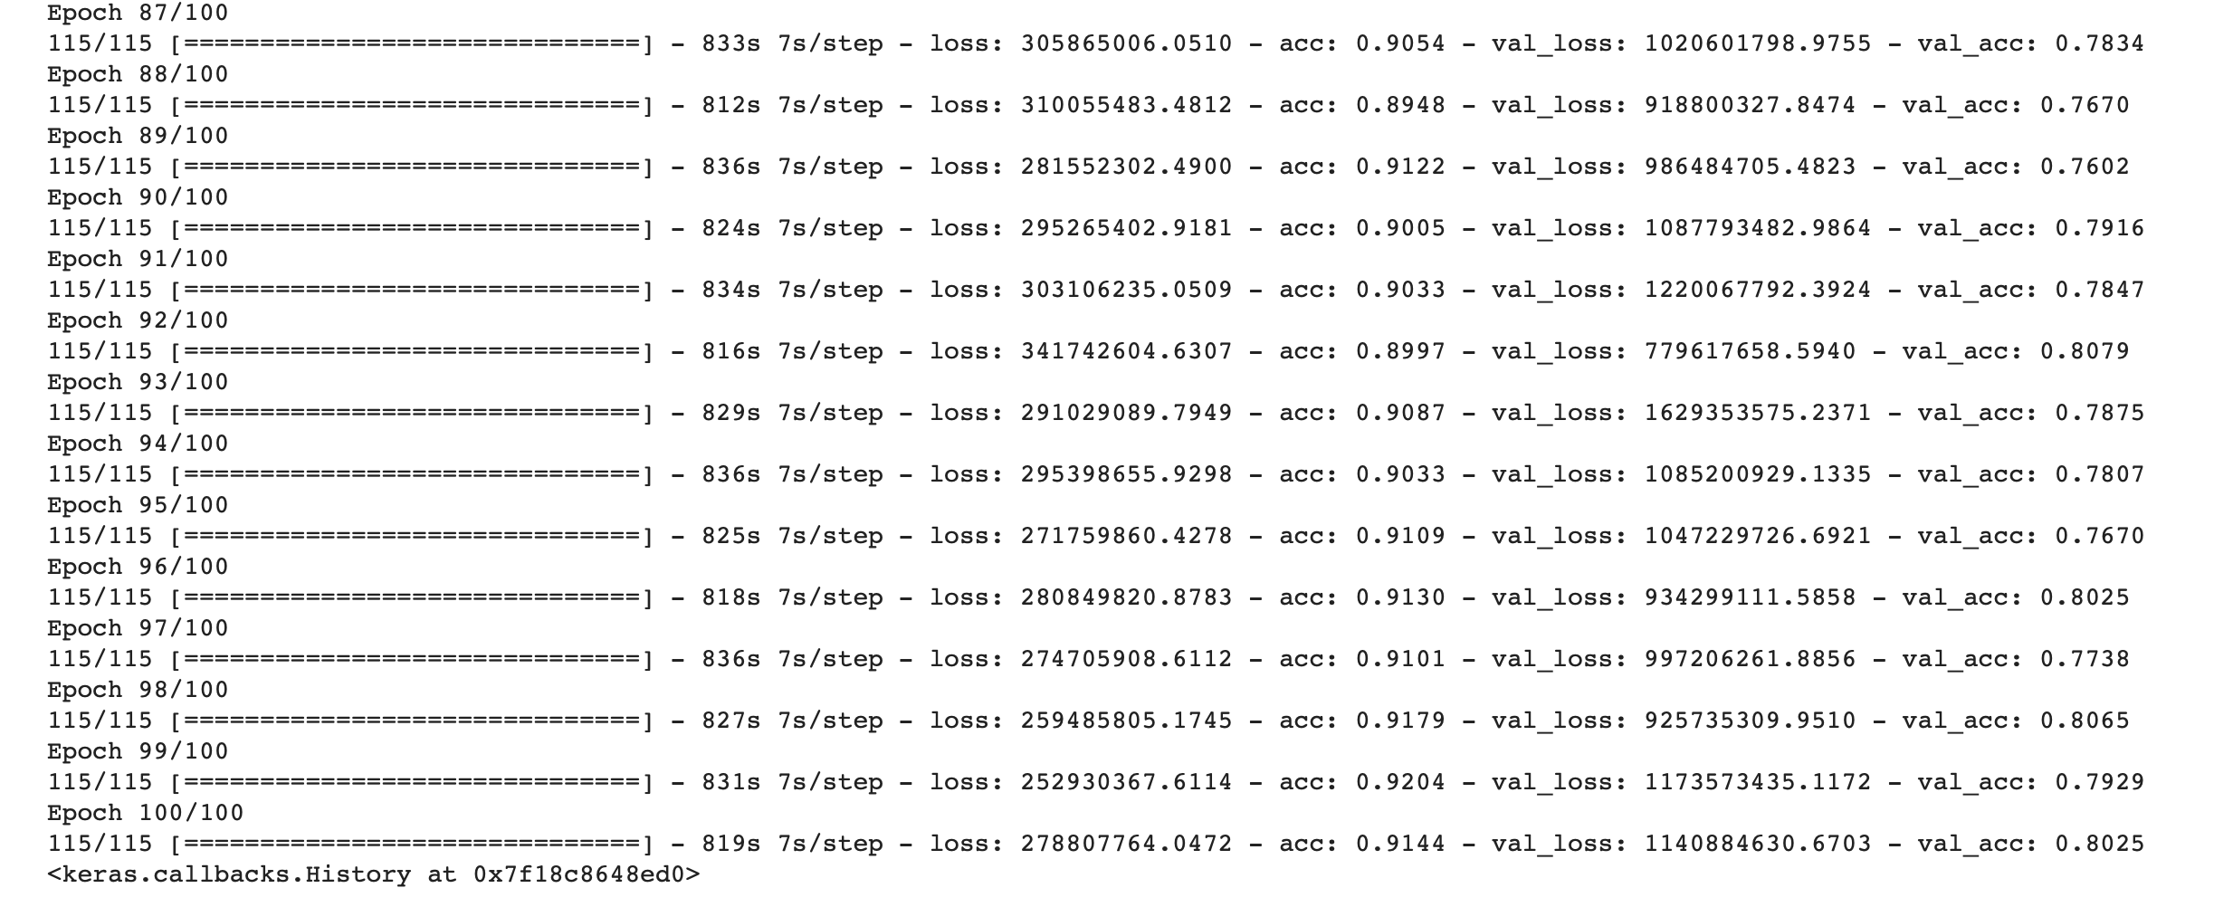

4.2

11

**Chapter - 5 Summary and Conclusion**

**5.1 Summary**

The output of the given model gives a validation accuracy of 80% and training data accuracy of 90%. As the VGG-19 model is deep it requires higher computation time on such big data sets. Still it is faster as compared to other networks like Resnet which require very high computation time. The residual networks are useful in passing such low resolution images into deeper neural networks which are in turn beneficial in obtaining good features. Batch normalization and dropout layers are useful in reduction of overfitting and helps the model to learn rather than memorize.

**5.2 Conclusion**

In a nutshell VGG-19 network can be used to predict the level of Diabetic Retinopathy using modifications in the network. The basic modifications are the residual connections in the network. Also using the batch normalization in VGG net to decrease overfitting and dropout for the same reason. Real time data augmentation is very important in a dataset with less number of images. The accuracy of the model is fair.

12

**References**

[www.kaggle.com](http://www.kaggle.com)

[www.medium.com](http://www.medium.com)

[www.keras.io](http://www.keras.io)

[www.medicalnewstoday.com](http://www.medicalnewstoday.com)

[www.mayoclinic.org](http://www.mayoclinic.org)

13